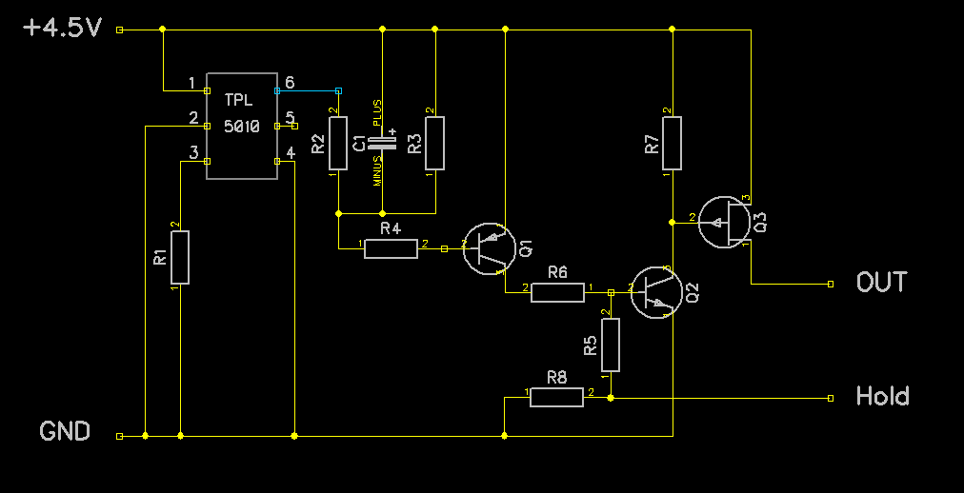
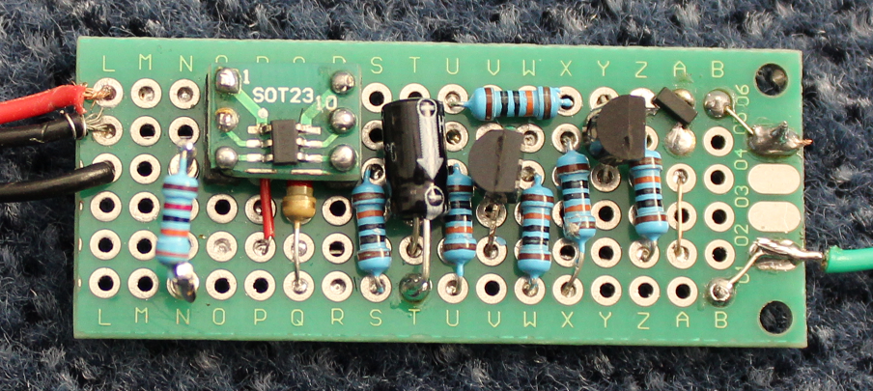
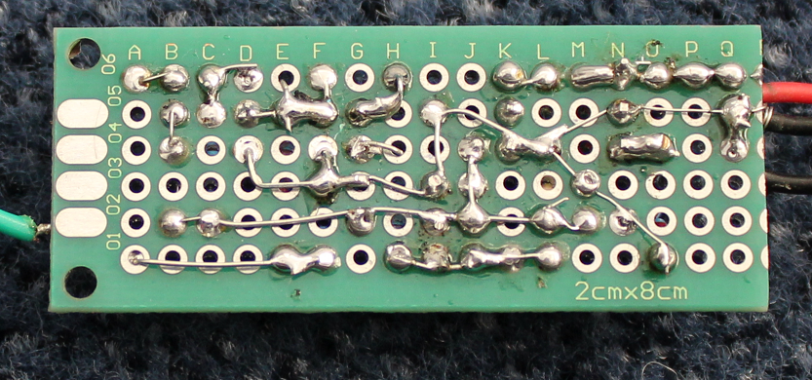
Low power system for LoRa end nodes.

Introduction.
LoRa end nodes are often battery powered. In order to save battery usage the node is put into a deep sleep most of the time. The node awakes normally when data read from a sensor must be sent to the LoRa network.
In deep sleep mode, the node normally consumes 3 or more µA.
This document describes a power control system that consumes less than 1 µA during idle mode.

Low power system.
The power supply presented here is designed to switch power on a fixed interval basis. The attached device (for example a LoRa end node) will be powered up, perform its task and then switch the power supply off.

The timing of the power-up interval is done by using a TPL5010 “Nano-power system timer”. The TPL5010 consumes only 35 nA in idle mode. The interval time can be set by means of a resistor to maximal 2 hours.

The end stage of the circuit is a P-channel MosFet (AO3407), capable of driving 3 A.

Schematics.
Fig. 1
Input voltage (for example 3 AA batteries) is 5.5 V max. For low power consumption, none of the three transistors are conducting and the capacitor C₁ is discharged in idle mode.

Part list.
TPL5010 | Nano-power system timer. 6 lead SOT23.
R₁ | Timer interval selection, for example 57.44 kΩ for 10 minutes. For testing, use a 10 kΩ resistor to create an interval of about 8 seconds.
R₂ | 1 kΩ
C₁ | 10 µF. Selects the minimal “ON”-time. About 2 seconds with10 µF.
R₃, R₄, R₅, R₆, R₇,R₈ | 100 kΩ
Q₁ | S9015 transistor PNP or similar.
Q₂ | S9014 transistor NPN or similar.
Q₃ | P-channel MosFet (AO3407), 30V, 3A, R_{DS} < 87mΩ

Theory of operation.
The TPL5010 generates a “reset”-pulse of 320 msec on pin 6 (open collector). This pulse is often too short to start a micro controller, usually the power-on time is about 1 second. Therefore the pulse length is stretched to about 2.4 seconds by R₃ and C₁. The pulse is shaped by T₂ and T₃.
The interval depends on the value of R₁. See the data sheet of the TPL5010 for a table with time intervals. Note that changing the value of R₁ has its effect after power-up of the circuit.
The HOLD signal must be driven HIGH by the micro controller of the LoRA end node if the required processing time is longer than the duration of the stretched pulse. As soon as the end node has finished it job, the HOLD signal can be withdrawn, effectively turning the power system OFF.

Prototype.
I made a prototype for this on a perfboard. It looks like this:

Fig. 2
The green wire is for the hold signal. The FET is in the top right corner, near the letter “A”. R₁ is mounted on two pins for easy replacement. It is positioned near letter “N”.

The back side:

Fig. 3

PCB.
A print for this circuit has been designed by Kishor Kumar. With the mounted components it looks like this:
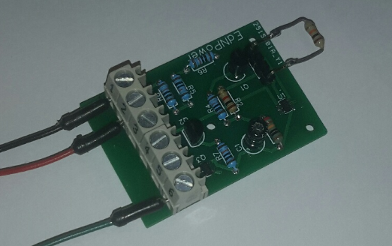
R1 is mounted on a 2 pin header for easy replacement.

Power measurements.
I was not able to measure the idle power consumption, as I have a multimeter with a resolution of 1 micro ampere. After a few seconds the power consumption should theoretically be far below 1 µA.

Useful extension.
You may add a button between pin 1 and 3 of the TPL5010 to start the power cycle manually.

Limitations.
The end node is completely shut down in idle mode. The result is that there is no longer a battery backed-up ram memory available in the end node to store data. In LoRa end nodes this memory is often used to hold the sequence number (frame counter) of the messages to the LoRa network.
So by using this power supply you may opt to not use incrementing frame counter. In that case make sure to uncheck the “Frame counter Checks” of your device in the settings on the TTN console.
A much better way is to use the flash memory to hold the frame counter. Normally the flash can withstand 10000 write operations per cell, that’s at least 1 years if your node send data every hour. And probably 100 or more years if you do some wear-leveling. If you have a battery back-upped real time clock in your node, you may also use the RAM memory of the RTC.

